PC A IP settings have been adjusted:  
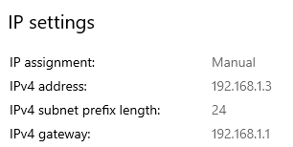  
Pings were unsuccessful as the switch has not yet been configured with the given IP

S2 at seat SOU-C128-26 has initial password “cisco” while the password to enable is “class”

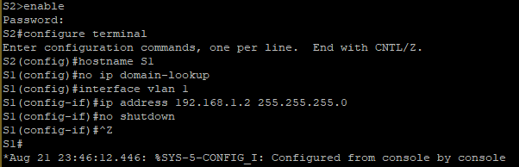

Pings still were not successful

What is the OUI portion of the MAC address for PC A?

8C-EC-4B

What is the serial number portion of the MAC address for PC A?

78-F4-2E

Vendor name?

Dell Inc

MAC address for VLAN 1 on S1?

A4-10-B6-F6-E8-C0

MAC serial number?

F6-E8-C0

What does bia stand for?

Burned in address

Why does it show the same MAC address twice?

To confirm that the reporting MAC address and the physical MAC address is the same

Layer 2?

a410.b6f6.e8c0

Layer 3?

192.168.1.2

No the MAC address of PC-A was not present likely due to the pings failing so it was never introduced to the table

Why would you need to know the MAC address of a device?

You might need to know the MAC address of a device to determine which device is communicating if it doesn’t have a static IP address. A MAC address is also useful as a serial number to be able to track equipment.